Steps for Installing Automation Software

1. Java installation
2. Intellij installation
3. Selenium installation

**Java installation**

1. Install Jdk
2. Configure Environment variables

Go to Advanced System settings. Go to Environment variable. System Variable

Enter variable name: Java_Home

Enter variable value: path where jdk is installed(c:\programfiles\jdk)

1. Install JRE

Steps for installation of JDK

1. https://www.oracle.com/technetwork/java/javase/downloads/jdk8-downloads-2133151.html
2. Navigate Click “AGREE AND PROCEED” if it is pop-up.
3. Scroll to “**Java SE Development Kit 8u192**”
4. Click “**Accept License Agreement**”
5. Based on you windows operating system (See note1 at bottom of page)
6. Click on “jdk-8u192-windows-i586.exe” for 32-bit(x86)
7. OR
8. Click on “jdk-8u192-windows-x64.exe” for 64-bit(x64)
9. **If there is not folder in C driver, please create folder name with “Soft” in C drive.**
10. Once downloaded, move this file to folder/directory (C:\Soft)

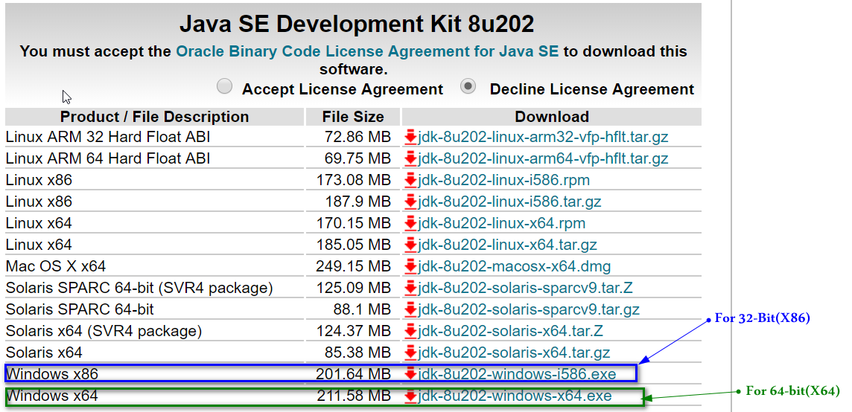

*Note1: To****find****out if your computer is running a****32****-bit or****64****-bit version of Windows in Windows 7 or Windows Vista, do the following:*

1. *Open System by clicking the Start button, right-clicking Computer, and then clicking Properties.*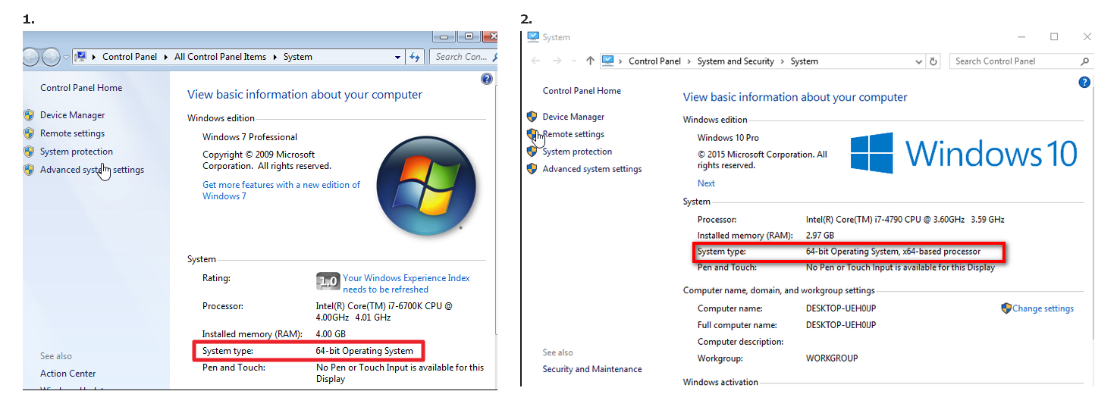

Download IntelliJ IDEA

1. Navigate to URL:

<https://www.jetbrains.com/idea/download/#section=windows>

1. Click on button “Download” under Community.
2. Once downloaded, move this file to folder/directory (C:\Soft)

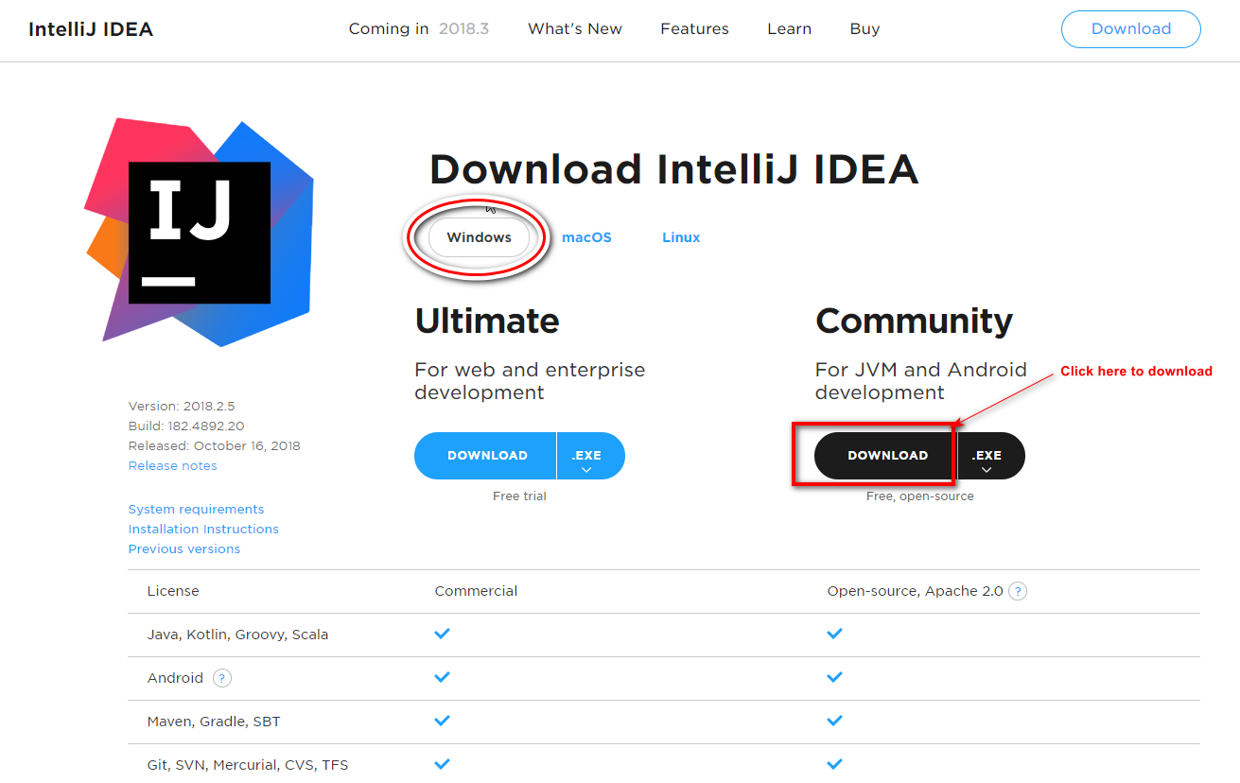

Download selenium

1. Navigate to URL <https://www.seleniumhq.org/>.
2. Download Java Client

Download latest version of selenium server (3.141.59).

Same version of java client

Download selenium Web driver

1. Latest version for Chrome

2. Latest version for Firefox

3. Latest version for Internet Explorer